**Applecross SHS**

**Year 10 Earth and Space**

**Topic Test - COMMON**

Name: ______________________

MCQ: ________ /15 Written: ______ /10 Total: _________ /25

(Time allowed: 35 minutes)

**SECTION A: MULTIPLE CHOICE ANSWER SHEET**

**PART 1:** Multiple choice Section. – Answers **(15 marks)**

|  |  |  |  |  |  |  |  |  |  |  |  |  |  |  |  |  |  |  |  |
| --- | --- | --- | --- | --- | --- | --- | --- | --- | --- | --- | --- | --- | --- | --- | --- | --- | --- | --- | --- |
| 1 | a | b | c | d | e |  | 6 | a | b | c | d | e |  | 11 | a | b | c | d | e |
| 2 | a | b | c | d | e |  | 7 | a | b | c | d | e |  | 12 | a | b | c | d | e |
| 3 | a | b | c | d | e |  | 8 | a | b | c | d | e |  | 13 | a | b | c | d | e |
| 4 | a | b | c | d | e |  | 9 | a | b | c | d | e |  | 14 | a | b | c | d | e |
| 5 | a | b | c | d | e |  | 10 | a | b | c | d | e |  | 15 | a | b | c | d | e |

**SECTION A: MULTIPLE CHOICE**

1. 1. The Oort cloud in our solar system is believed to contain

(a) asteroids

(b) planets and dwarf planets

(c) comets

(d) meteors

2. One of the following is a possible correct sequence for a star. Circle it.  
(a) protostar -> main sequence star -> brown dwarf

(b) protostar -> main sequence star -> red giant -> white dwarf  
(c) protostar -> small main sequence star -> red super giant -> neutron  
(d) protostar -> large main sequence star -> supernova -> red supergiant -> black hole

3. Which of the following lists the objects in order from **least dense** to **most dense**

(a) black hole, neutron star, red giant, main sequence star

(b) main sequence star, red giant, neutron star, black hole

(c) red giant, main sequence star, neutron star, black hole

(d) neutron star, main sequence star, red giant, black hole

4. The asteroid belt is located

(a) between Earth and Mars

(b) between Mars and Jupiter

(c) between Jupiter and Saturn

(d) between Uranus and Neptune

(e) outside Neptune’s orbit

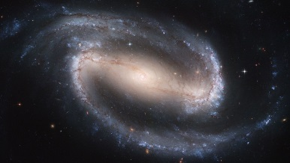 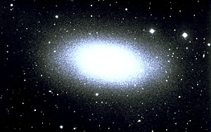 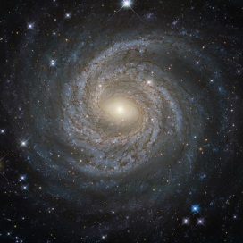 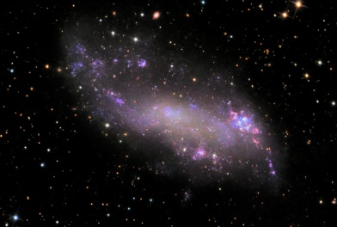

5. The galaxies above would be classified (in order from left to right) as

(a) spiral, elliptical, barred spiral, irregular

(b) irregular, elliptical, spiral, barred spiral

(c) spiral, irregular, barred spiral, elliptical

(d) barred spiral, elliptical, spiral, irregular

6. Where is the energy of the Sun actually produced in fusion reactions?

(a) the core

(b) the radiation zone

(c) the surface

(d) the corona

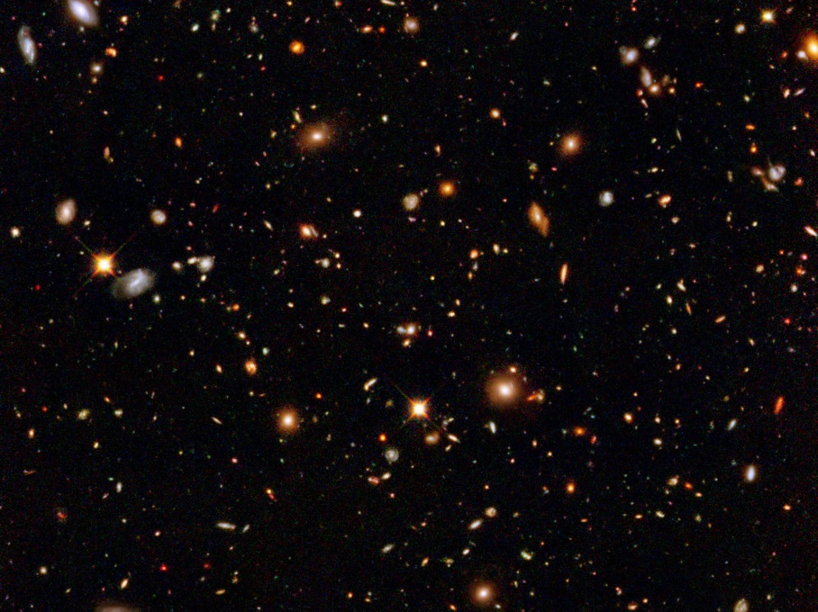

7. The picture above shows the famous ‘Hubble Deep Field’ image taken by the Hubble telescope pointing in just one location outside of our galaxy. Each light is a galaxy. The photo assisted researchers to estimate the number of galaxies in the observable universe. Scientists estimate that this number is closest to:

(a) 1 million

(b) 100 million

(c) 1 billion

(d) 100 billion

8. Which key observation led to the Big Bang theory of the creation of the universe?

(a) most galaxies are moving away from our galaxy

(b) some galaxies are moving towards our galaxy

(c) the mass in the universe is mainly made up of hydrogen and helium

(d) there are many different types of stars

9. Which is true according to the Big Bang theory?

(a) All elements in the universe were created in the Big Bang

(b) Light elements, like helium and hydrogen, were created by the Big Bang and heavier elements were created later by fusion in stars

(c) Heavy elements were created in the Big Bang and light elements, like helium and hydrogen, were created by fusion in stars

(d) None of the above.

10. The best definition of a sun spot is

(a) A site of a solar storm on the Sun

(b) An area of the Sun which is black

(c) An area on the Sun which is cooler than other areas.

(d) The site of a meteor or asteroid impact.

11. Fusion in our Sun is best described as:

(a) Burning hydrogen to produce energy

(b) Converting helium into hydrogen plus energy

(c) Producing energy from high pressures and temperatures as the core of the Sun

(d) Converting mass into energy

12. The correct order for layers of the Sun is:

(a) Core, convective zone, radiative zone, surface, corona

(b) Core, convective zone, radiative zone, corona, surface

(c) Core, radiative zone, convective zone, surface, corona

(d) Core, radiative zone, convective zone, corona, surface

13. In the future, our Sun is likely to become a..

(a) red dwarf

1. (b) white dwarf
2. (c) supernova
3. (d) neutron star

14. A comet is best described as

(a) A dirty snowball

(b) A large metallic rock

(c) A fiery, burning object orbiting the Sun

(d) A dwarf planet in an eccentric orbit

15. A black hole at some stage in its life was in the form of

(a) A white dwarf

(b) A star similar to our sun

(c) A red super giant

(d) A neutron star

**SECTION B: WRITTEN SECTION**

16. Describe three key features of the nebula theory of the creation of the Solar system. (3 marks)

__________________________________________________________________________________

__________________________________________________________________________________

__________________________________________________________________________________

__________________________________________________________________________________

__________________________________________________________________________________

17. Exoplanets are planets found orbiting stars other than our Sun. They are usually too small to see directly, even with the most powerful telescopes. Explain one method which astronomers can use to identify the existence of an exoplanet. Use a diagram to support your answer. (3 marks)

__________________________________________________________________________________

__________________________________________________________________________________

__________________________________________________________________________________

__________________________________________________________________________________

__________________________________________________________________________________

18. State one way we can observe the effect of large solar flares on Earth. (1 mark)

__________________________________________________________________________________

__________________________________________________________________________________

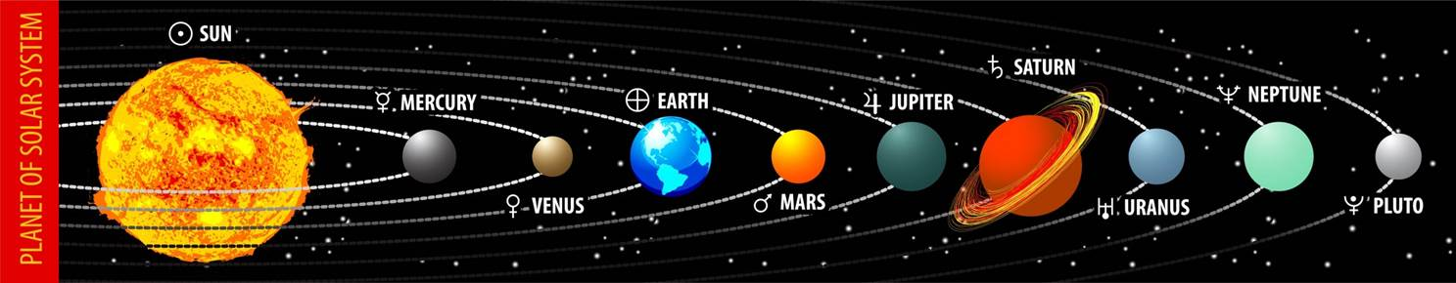

19. State three fundamental ways in which the picture above of the solar system and its planets is not representative of the real thing (3 marks)

__________________________________________________________________________________

__________________________________________________________________________________

__________________________________________________________________________________



**Applecross SHS**

**Year 10 Earth and Space**

**Topic Test – PATHWAY 1 EXTENSION**

Name: ______________________

MCQ: ________ /10 Written: ______ /10 Total: _________ /20

(Time allowed: 20 minutes)

**SECTION A: MULTIPLE CHOICE ANSWER SHEET**

**PART 1:** Multiple choice Section. – Answers **(10 marks)**

|  |  |  |  |  |  |  |  |  |  |  |  |  |
| --- | --- | --- | --- | --- | --- | --- | --- | --- | --- | --- | --- | --- |
| 1 | a | b | c | d | e |  | 6 | a | b | c | d | e |
| 2 | a | b | c | d | e |  | 7 | a | b | c | d | e |
| 3 | a | b | c | d | e |  | 8 | a | b | c | d | e |
| 4 | a | b | c | d | e |  | 9 | a | b | c | d | e |
| 5 | a | b | c | d | e |  | 10 | a | b | c | d | e |

1. Choose the correct statement about stars

1. (a) A star that is very luminous and cold must be large
2. (b) A star that is very luminous and cold must be small
3. (c) A star that is very luminous must be large
4. (d) A star that is very cold must be small

2. Two stars A and B have the same luminosity but A is much bigger than B. Which of the following must be true?

(a) Star A must be bluer than B   
(b) Star A must be hotter than B   
(c) Star A must be a supernova

(d) Star A must be redder than B

3. The effective temperature of a star is related closely to its

(a) age

(b) mass

(c) colour

(d) size

4. Stars like the Sun are mainly made up of plasma. The best definition of plasma is a hot, gas-like substance made up of

(a) mostly neutrons

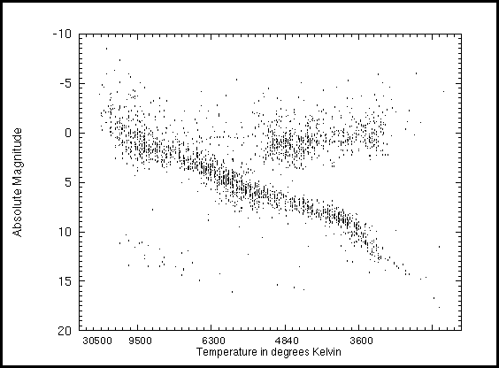(b) atoms

(c) electrons and atomic nuclei

(d) solar wind

B

A

5. Area B in the H-R diagram (right) contains  
(a) Red giants/supergiants  
(b) Blue giants  
(c) Main sequence stars  
(d) White dwarfs and black holes

E

D

C

6. In the H-R diagram above, a white dwarf would be located in area

(a) A  
(b) B  
(c) C  
(d) D

(e) E

7. An ambulance’s siren sounds different (has a different pitch) when it is coming towards you to when it is moving away from you or if it is stationary. This difference is due to the Doppler effect. The best explanation for the Doppler effect when the siren is moving **towards** you is:

(a) The sound waves are compressed and the pitch of the sound is higher

(b) The sound waves are compressed and the pitch of the sound is lower

(c) The sound waves are stretched and the pitch of the sound is higher

(d) The sound waves are stretched and the pitch of the sound is lower

**8.** The diagram below shows the relative position of a comet and its tail at different times as it passes near the Sun. The tail of the comet streams away from the Sun because:

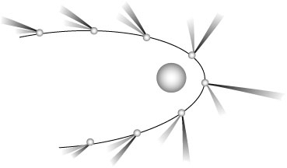

(a) the solar wind carries the particles in the tail away from the Sun

(b) radiant energy from the Sun melts the ice crystals of the comet which then reforms in the shadow of the comet

(c) the motion of the comet leaves the tail streaming behind

(d) the force of the comet moving around the Sun causes the tail to swing outwards like a water skier behind a boat

9. Cosmic materials which are burned up as they pass through the Earth’s atmosphere are called:

(a) asteroids

(b) meteorites

(c) meteors

(d) meteoroids

10. The equation E = mc2 canbe used to explain why

(a) the sun’s mass is slowly reducing

(b) light travels through the vacuum of space

(c) large masses like stars are required to produce energy

(d) energy is required to fuse atoms

**SECTION B: WRITTEN SECTION**

11. The Andromeda galaxy is our nearest neighbouring galaxy. It is moving towards us (the Milky Way galaxy) at 110 km per second. Explain:

a) The method astronomers used to determine this (2 marks)

__________________________________________________________________________________

__________________________________________________________________________________

__________________________________________________________________________________

b) Why the direction of Andromeda’s motion unusual? (1 mark).

__________________________________________________________________________________

12. The curve below shows the emission spectrum of a typical yellow main sequence star similar to our Sun. It shows the yellow star giving light out at a range of colours (wavelengths) peaking near the middle of the visible light area (blue to red light). Draw another curve which shows the expected spectrum of a brighter and hotter star (2 marks)

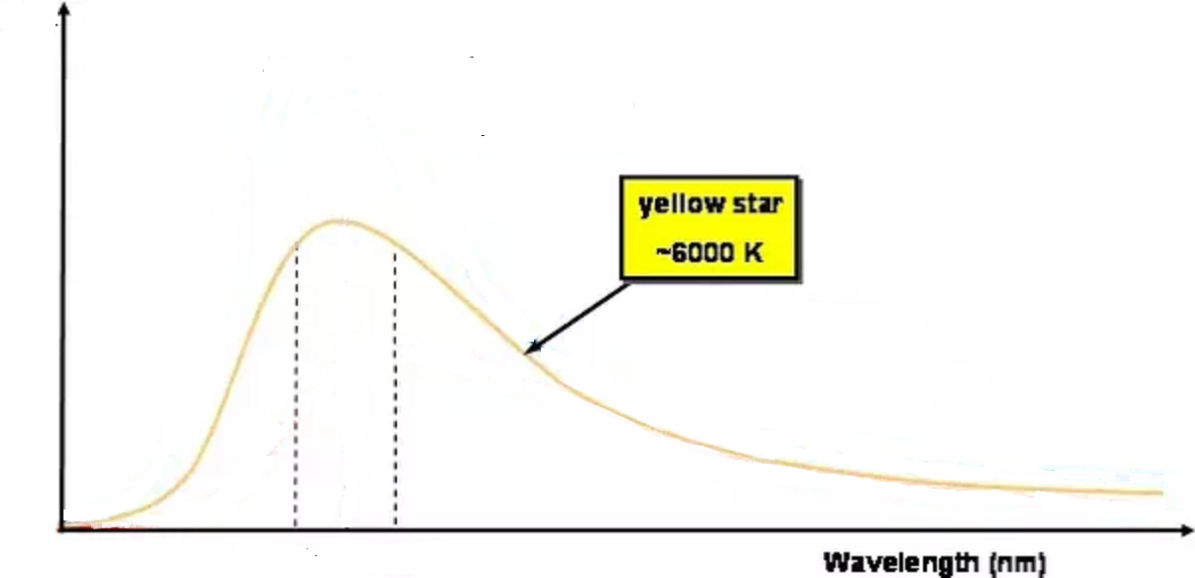

Blue Red

light light

Light intensity

13. Explain one possible future for a star which is 15-20 times larger than our Sun (2 marks).

__________________________________________________________________________________

__________________________________________________________________________________

__________________________________________________________________________________

14. Explain how a light spectrum can be used to identify the composition (elements) of a star (3 marks)

__________________________________________________________________________________

__________________________________________________________________________________

__________________________________________________________________________________

__________________________________________________________________________________